

**NETWORKING & SYSTEM ADMINISTRATION LAB**

**Experiment No.: 1**

**Aim**

Install the latest version of Ubuntu on an Oracle VM VirtualBox.

**Procedure**

**STEP 1: start to install oracle VM VirtualBox 6.1.32 in our computer**

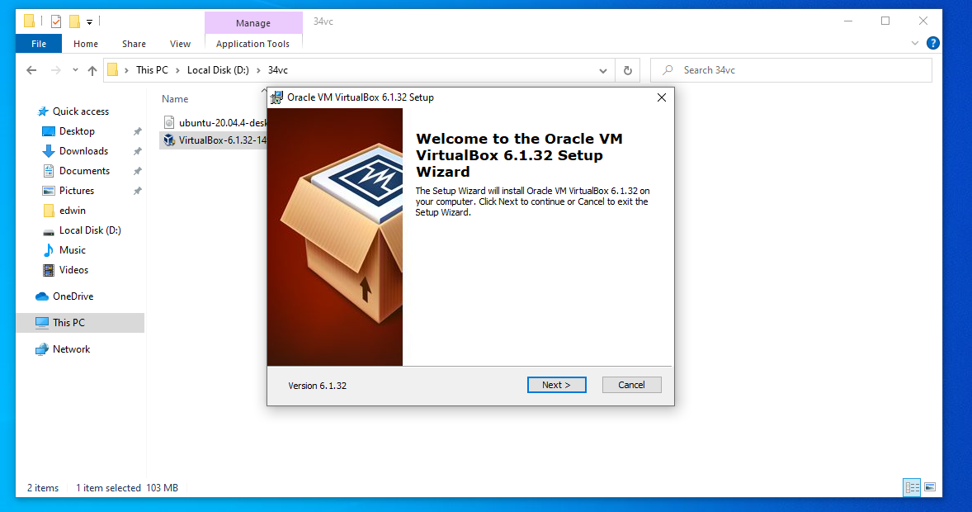

**STEP 2.To custom setup for change the way features will be installed**

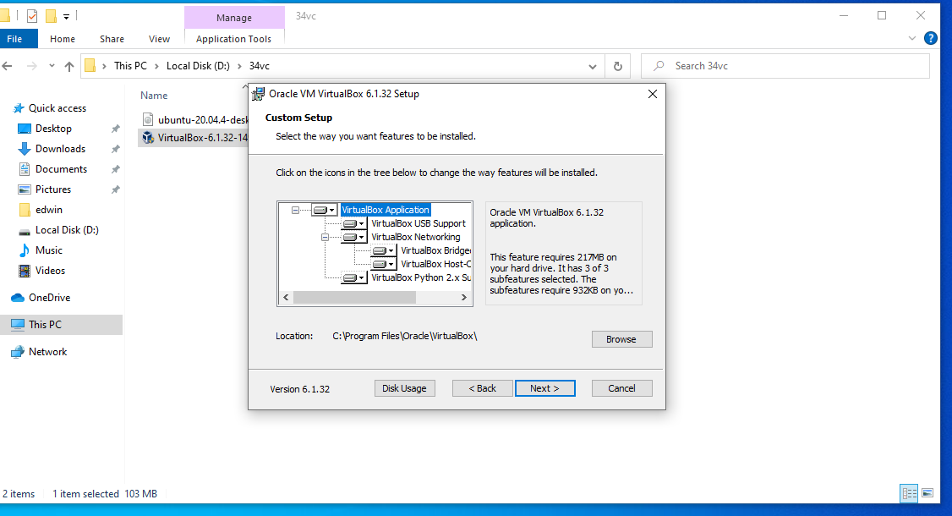

**Step 3: Choosing the options for the features installed**

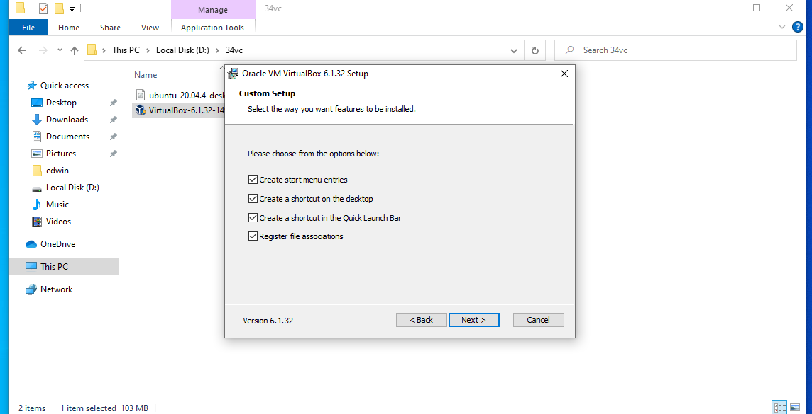

**Step 4: proceed for the installation from a networking interfaces**

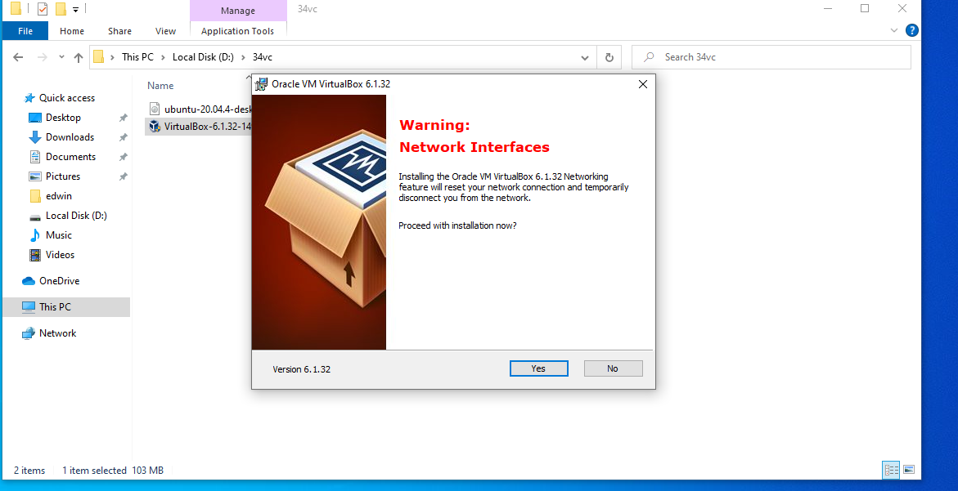

**Step 5: click install which ready to installation**

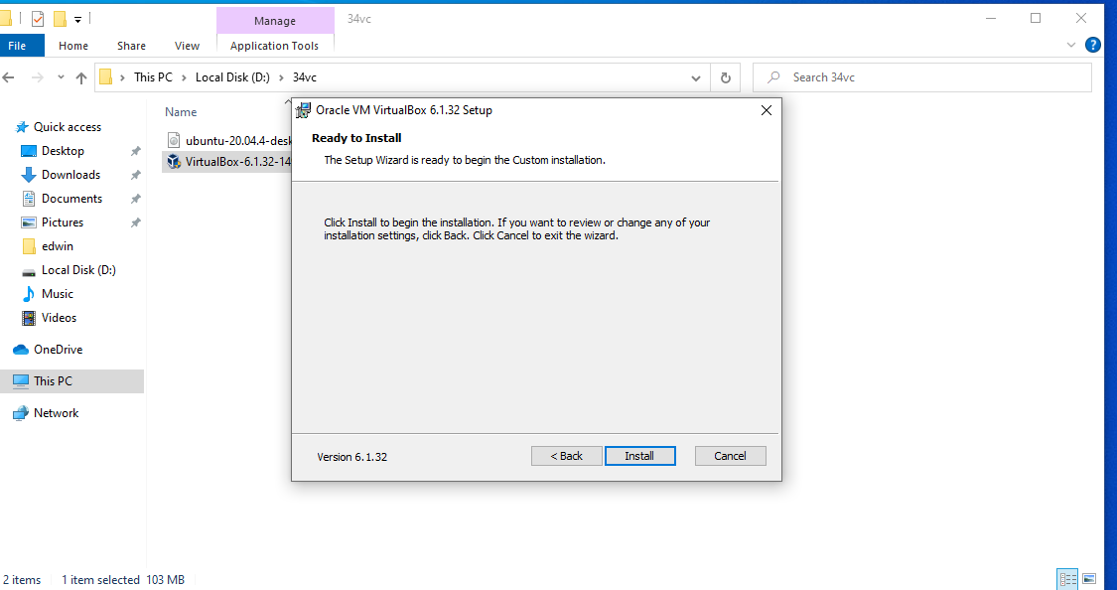

**Step 6: Install the device software**

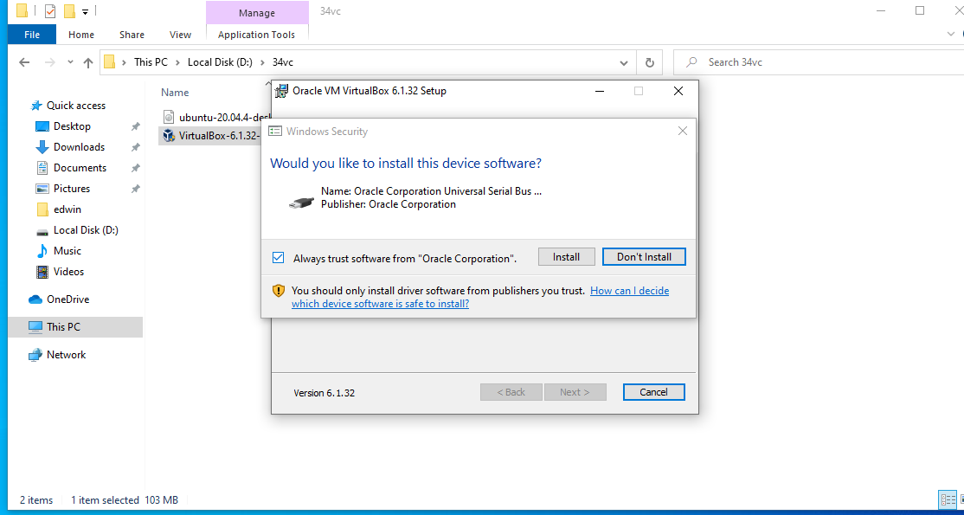

**Step 7: Finish the installation**

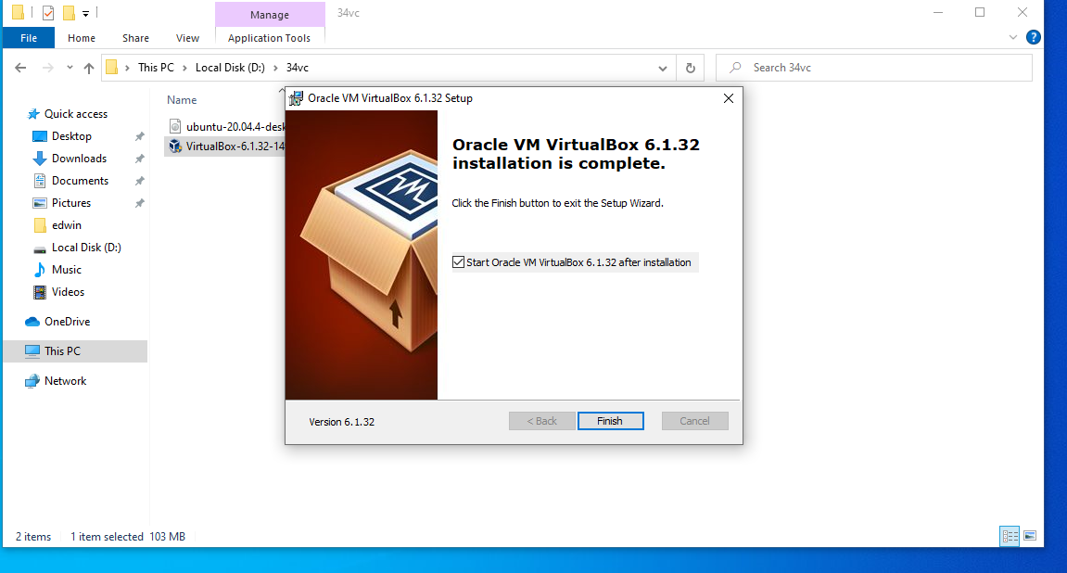

**Step 8: Open the VirtualBox**

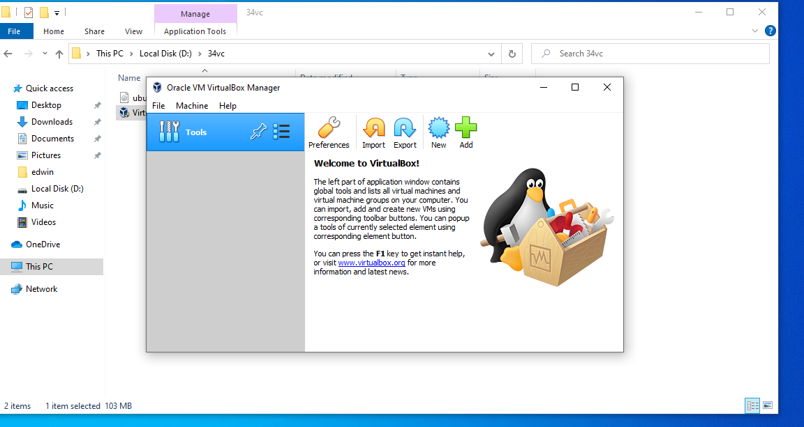

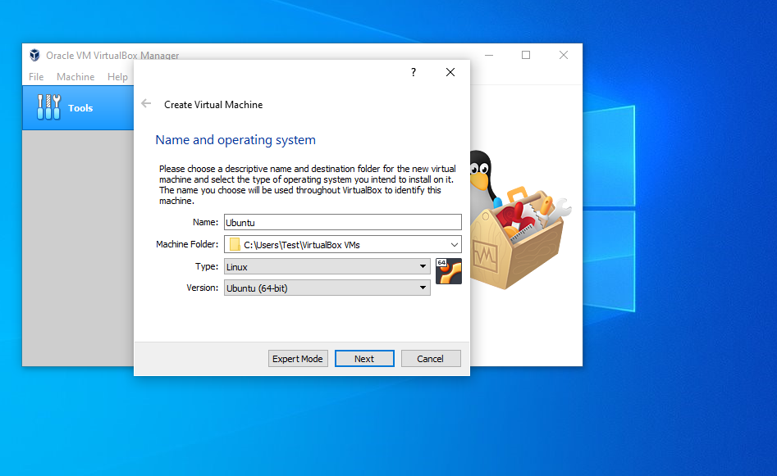



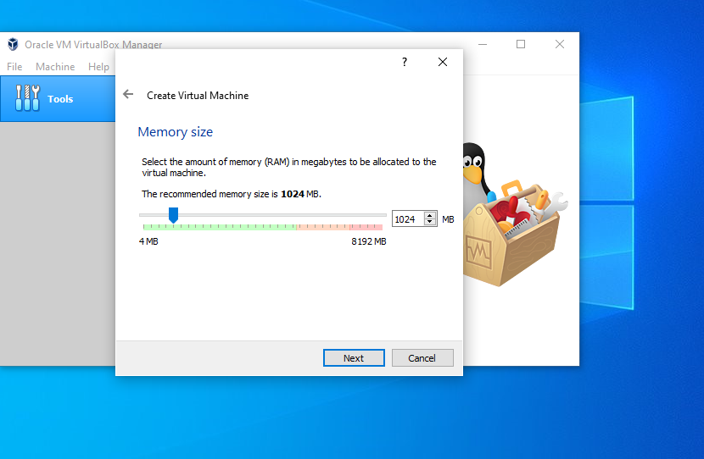



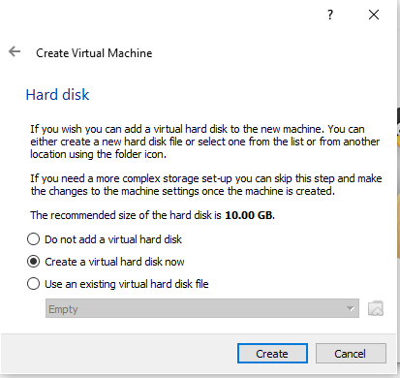

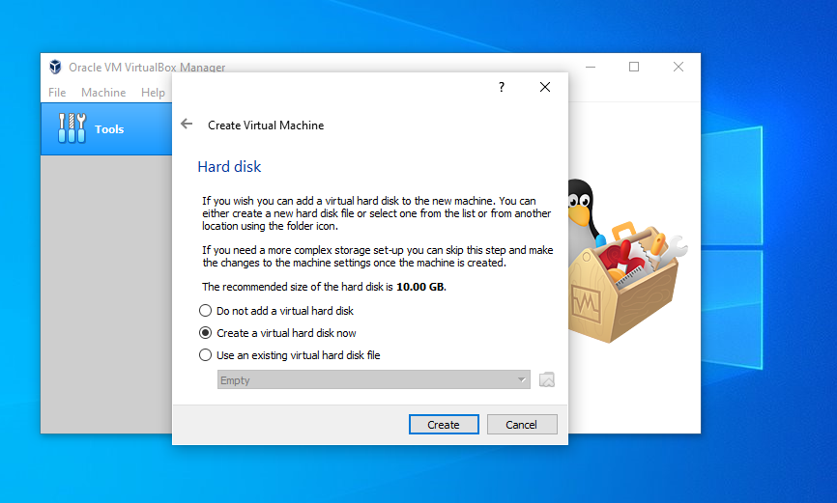

**STEP 10:Set hard disk file type as VDI and click “next”**

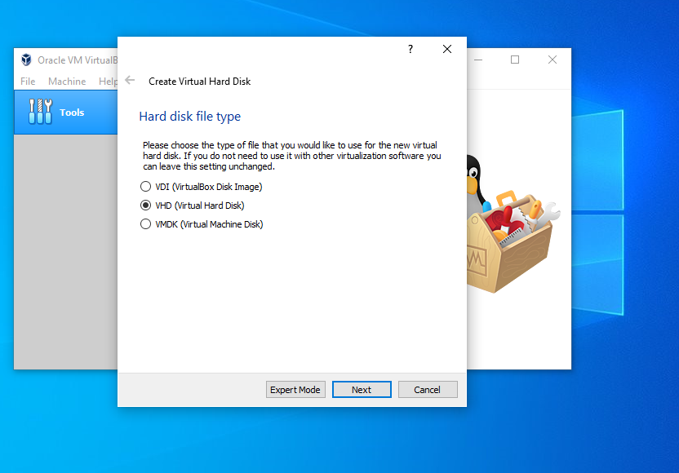

**STEP 11:Set storage on physical hard disk as dynamically allocated**



